Voice Coach — Análisis de voz
Idioma: English · Duración: 32s · Palabras: 50 · Ritmo: 95 ppm · Positividad: 72% · Muletillas: 0 · Generado: 7/11/2026, 1:21:11 PM

Métricas
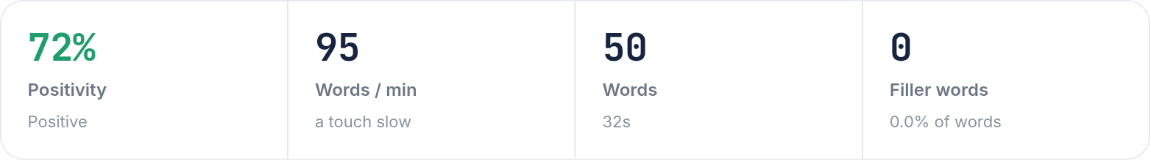

Arco de sentimiento
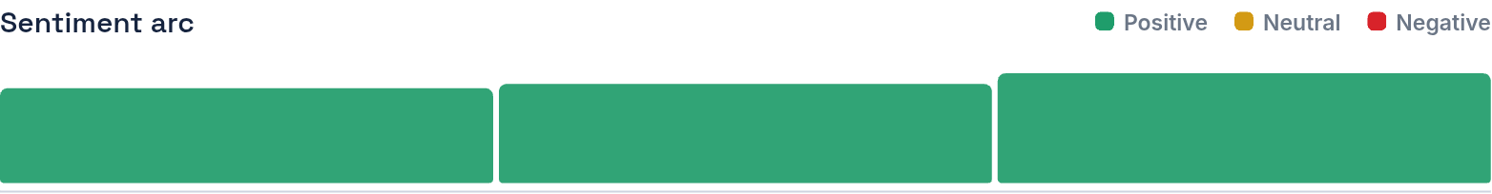

Transcripción
When big messages from USA, come to Latin America, they are looking for competitive salaries and others who can speak or choose left. I decided to pursue a career in a corporate business decision team, a co-endrian, a inspiring chemistry and English. It her work, we can achieve two goals.
Color del texto — Verde: positivo · Amarillo: neutral · Rojo: negativo

